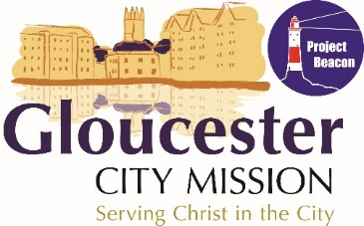

Survive the Night 10th October 2020

We are delighted that you would like to consider signing for Survive the Night 2020 to raise funds to support the Gloucester City Mission. This is our 5th year of running this event but we hope to encourage people to sleep out either at their workplace, church, school, back garden etc

REGISTRATION FORM:
- Please complete the form attached (FORM A) and email it to kevin@gloscitymission.org.uk.

SPONSORSHIP FORM:
Please encourage sponsors to Gift Aid their donations
- You can seek sponsorship using this form and then pay in face to face or send a cheque to the address below
- Or/and, you can ask for online donations – to do this:
  - Go to www.virginmoneygiving.com/fund/survivethenight2020
  - You can either register as a Fundraiser for us and link to the event page that we have set up or you can encourage people to make online donations and in the Messages box leave a comment to say that the donation is for the STN

The Small Print:
- By taking part in Survive the Night you pledge to aim to raise funds towards the work of Gloucester City Mission
- You agree that you are participating in the event at your own risk and that the organisers are not responsible for any injury, loss or damage, which may occur to you or your property during the event.

FORM A

Survive the Night in your workplace, school, church, garden, organisation (or anywhere else) Registration Form

Name:
Address:
Telephone: |  | Mobile:
Email:
Group/Organisation (If Applicable)
Do you have any on-going medical conditions? (please include any allergies)
How did you hear about this event?
Location of Sleepout |  | Date of Sleepout
We would welcome photographs during this event. If you send us any photos do you consent to photographs being taken and used to both celebrate this event and promote future events raising funds for the those in need in Gloucester:
 |  |  |  | Yes/No
Emergency Contact
Name:
Address:
(If different to above)
Telephone:
Relationship to Participant |  | Mobile:
I agree to the terms as listed on page 1 of this pack under the title ‘Small Print’
I would/would not like to find out added to the GCM email list to receive newsletters and information
Signature: |  | Date:
Please complete this section if you are under 18
Date of Birth:
Parent/Guardian’s Details
Name:
Address:
(If different to above)
Telephone: |  | Mobile:
I give permission for my child to attend the event with the following nominated adult
Adult Name:
Relationship to child:
Signature: |  | Date:

Please return this form to kevin@gloscitymission.org.uk

